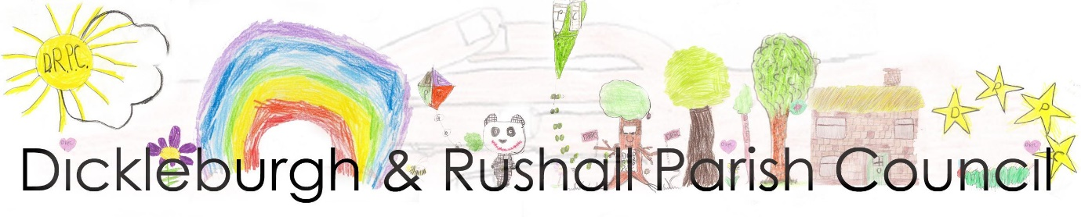
Parish Clerk: Ann Baker, ‘Ganders,’ Langmere Road, Rushall, Norfolk, IP21 4QB

Dickleburgh and Rushall Parish Council’s response to the GNLP consultation process

GNLP propose enabling the building in the region 40,000 – 50,000 homes across Norwich, Broadlands and South Norfolk. The building of homes will require infrastructure. Roads will be constructed, cabling, piping, lighting, fuel will all be purchased and utilised to enable the building.
1 There appears to be no strategy put forward by the GNLP to identify the carbon footprint of these activities.
2 There appears to be no strategy to ensure that once built the houses and infrastructure will have a reduced impact upon the environment and mitigate against carbon release or environmental outcomes such as flooding.
We would like answers to the following questions:
1 What will be the environmental impact of building the additional homes identified by the GNLP and the supporting infrastructure across the city and districts?
2 What is the calculated cost of CO2 emissions and environmental impact of the whole GNLP process?
3 What requirement is being made of land owners and developers to mitigate against the environmental impact of their specific development?
4 It has been suggested that CIL monies can be used to offset the environmental impact of a development. The CIL monies are principally used to provide infrastructure needed within the community to facilitate the additional homes and families. What new monies are going to be provided specifically to accommodate the environmental impact of the development?

Dickleburgh and Rushall Parish Council Proposals:
1 Offsetting at the point of build. All new building projects will be expected to have undergone a carbon assessment (tCo2e) and to publish the result at the time the application is made (prior to any decision by the planning authorities). This should be shared with the local community and additional requirements made upon the developer to mitigate against environmental damage. This could include: providing additional funding for the purchase of carbon offset capabilities, or providing additional habitats and environs for species, or providing offset land within the community for carbon capture.
All new builds should clearly identify the carbon-offset strategy they intend to utilize to meet the carbon offset requirements prior to consent being given.
2 Strategic Offsetting A. The GNLP should make the assessment (tCo2e) of the cost of implementing the GNLP in full. The GNLP should then mitigate the cost by creating a South Norfolk GNLP woodland. This could be a series of smaller woodlands linked that run across the South of the county across a large number of parishes.
3 Strategic Offsetting B. The GNLP should make the assessment (tCo2e) of the cost of implementing the GNLP in full. The GNLP should then mitigate the cost by creating a South Norfolk GNLP woodland. This could be located as a single large public woodland handed over to and managed by an organisation such as the Woodland Trust
4 Strategic Offsetting C. The GNLP should make the assessment (tCo2e) of the cost of implementing the GNLP in full. The GNLP should then mitigate the cost by creating a South Norfolk GNLP woodland. This could be woodlands planted in all the parishes that have housing through the GNLP process. These public woodlands would be managed by the Parish Councils.

Dickleburgh and Rushall Parish Council would value a considered response to the questions and proposals outlined above, in view of the developing national emphasis on creating a more sustainable environment and planet.
Yours sincerely,
Andrew P. Goodman
Chair of Dickleburgh & Rushall Parish Council

