Greater Norwich Local Plan Regulation 18 Consultation
Breckland District Council’s Officer Response
Breckland District Council generally supports the Greater Norwich Local Plan and its growth plans. A large proportion of Breckland District Council’s growth plans are concentrated in the same area of the Norwich – Cambridge Corridor and our main concerns are the cumulative impact of the growth on infrastructure particularly power which has been identified as a constraint in this area in the Greater Norwich Energy Study April 2019 and water as indicated in the Anglian Water Resources Management Study 2019. We are also particularly interested in the growth aspirations along the A47 at Honingham and Easton.
Reference | Description | Response
The Strategy Section 2:-Greater Norwich Spatial Profile Paragraph 81 Digital Infrastructure | “It aims to make high-speed broadband available to more than 95% of Norfolk’s premises by spring 2020. The next generation of mobile phone networks will be 5G, and the rollout is expected to commence in 2020.” | The Council welcomes this objective but seeks clarification as to whether the 95% of premises are in GNLP or in Norfolk.  Is the target date of Spring 2020 realistic?  Can GNLP confirm whether rural areas within GNLP have 5G or 4G?
The Strategy Section 3:-The vision and objectives for Greater Norwich. Economy Paragraph 113 | “This will include significant growth……… the Food Enterprise Park at Honingham…” | The map of the FEZ is not included in the pack. Further clarification is requested as to how this will relate to other proposed growth in that area
The Strategy Section 3:- The vision and objectives for Greater Norwich. Infrastructure. Paragraph 126 | .”electric vehicles will predominate throughout Greater Norwich and connected and autonomous vehicles (CAVs) will have become more commonplace, initially with taxis and shared demand responsive buses and ultimately for buses, deliveries and private vehicles.” | The Council welcomes this objective but seeks clarification, that in an area where the supply of power can be an issue for new developments, how will the demand on the Power grid from EVs be managed- particularly in those areas identified for major new development including the A11 tech corridor? Further detail on the criteria for charging points is sought including, for which types of development and type of charging.
The Strategy Section 4: -Addressing Climate Change Footnote 51 | “Norfolk County Council has adopted a target of achieving net zero carbon emissions by 2030 for council owned land and buildings and for travel. In addition, they will work towards carbon neutrality for the county, also by 2030”  Broadland District Council and South Norfolk Council are working on joint Environmental Policy Statement and Action Plan. Norwich City Council are working on a new Carbon Management Plan and have adopted a vision document which commits to carbon neutrality by 2050.The GNLP will support achievement of any objectives or targets identified in adopted local strategies.” | The Council welcomes this objective but seeks clarification as to how climate change policies will be monitored with differing targets on carbon neutrality across districts and at county level
Section 5 The Strategy Policy 1:- The Sustainable Growth Strategy Paragraph 168 | “No new settlement is proposed at this time as a significant proportion of the allocated sites are strategic scale commitments of 1,000 homes plus and the establishment of any new settlement is likely to take a long time. However, three new settlement sites have been proposed (at Honingham Thorpe, Hethel and Silfield). The longer-term development of a new settlement could be a suitable option in the future. This should be considered in the next review of this plan.” | We support the development strategy proposals and in particular that no new settlements are proposed at Honingham Thorpe, Hethel and Silfield. However, we would welcome the opportunity to engage with GNLP were these proposals to come forward in the future.
The Growth Strategy Paragraph 169 | ”The strategy distributes around 78% of the growth in the ‘Strategic Growth Area’. This area as shown in Key Diagram includes the A11 Tech Corridor…”  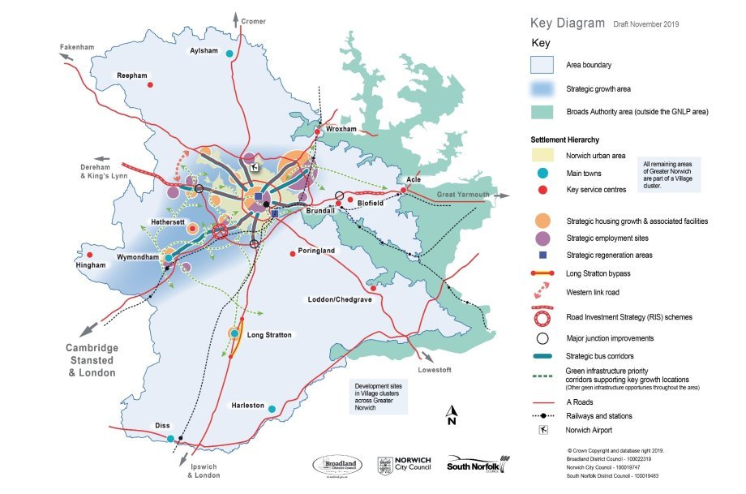 | For information Breckland also has planned significant growth along the A11 corridor at Attleborough, Snetterton Heath and Thetford.
The Growth Strategy: Map 7 Housing Growth Locations  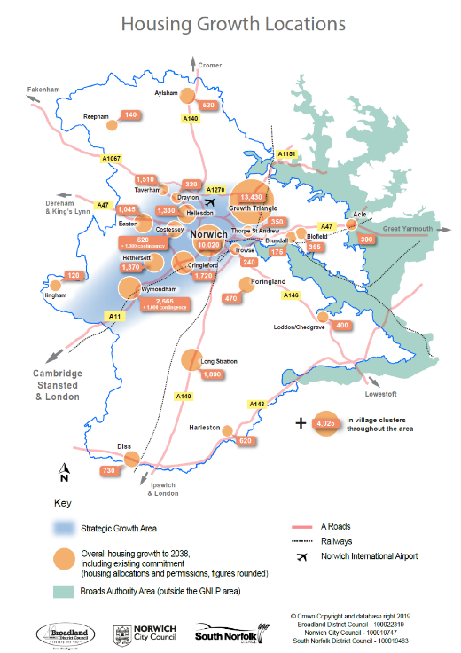 | Growth along A11 Corridor:  Housing:  - Cringleford 1,720  - Hethersett 1,370  - Wymondham 2,565 with an additional contingency +1,000  - South Norfolk village clusters  Employment  - Hethel  - Wymondham  Growth along A47  Housing:  - Easton 1,045  - Costessey 520  - Taverham  - Bawburgh  - Potential New Settlements @ Honingham Thorpe, Hethel, Silfield?  Employment Locations at Longwater and The Food Enterprise Park at Easton/Honingham | BDC seeks confirmation that the proposed growth from GNLP will not be of detriment to the growth planned within Breckland.  In particular the Council is concerned that the cumulative growth impacts on transport, power, water supply have been adequately addressed.  For information, BDC has significant growth in these areas with 4000 dwellings and employment land west of London Road at Attleborough, the significant employment growth plans for Snetterton Heath and housing and employment growth along A47 particularly at Dereham.  BDC has concerns whether the proposed improvements on A11 and A47 will be sufficient to meet the needs of the cumulative growth from the two planned areas. Equally is there sufficient Railway capacity to cope with increased growth.  Under the Duty to Cooperate, Breckland District Council would welcome the opportunity to engage with GNLP to explore a joint approach to any constraints which may arise as a result of the cumulative growth in both planned areas
Policy 1 The Sustainable Growth Strategy | “Most of the housing, employment and infrastructure growth is focussed in the Strategic Growth Area illustrated on the key diagram. This includes Greater Norwich’s part of the Cambridge Norwich Tech Corridor, including the Norwich urban area, Hethersett and Wymondham and key strategic jobs sites at Hethel and the Norwich Research Park.” | As above
Policy 1 The Sustainability Growth Strategy | “The preferred option (for distribution of development) in this plan combines concentration of most of the development in and around Norwich and on the Cambridge Norwich Tech Corridor” | As above
Policy 2 Sustainable Communities | All new development will provide a 20% reduction against Part L of the 2013 Building Regulations (amended 2016)  Appropriate non-housing development of 500 square metres or above will meet the BREEAM ‘very good’ energy efficiency stand, or equivalent successor” | The Plan needs a clear monitoring framework setting out how this will be monitored
Policy 4 Strategic Infrastructure Paragraph 217 | “The Greater Norwich Energy Infrastructure Study (March 2019) concludes that failure to address local energy constraints through local plan policy could threaten the delivery of growth in this plan” | The Greater Norwich Energy Infrastructure Study April 2019 identifies shortfalls in supply for new development proposed in the GNLP and will also impact on development outside GNLP. It refers to Sall Grid which supplies North Norfolk and Breckland along with Diss Grid which supplies West Suffolk and Breckland which are at full capacity.  Breckland District Council would welcome the opportunity to engage with GNLP to explore a joint approach to any constraints which may arise as a result of the cumulative growth in both planned areas
Policy 6- The Economy Paragraph 254 | The Norfolk and Suffolk Economic Strategy (NSES) recognise Norwich and Greater Norwich as one of six “priority places” Greater Norwich is also a key location within two other priority places; the A47 corridor and the Cambridge-Norwich Corridor | For information, Breckland District Council also is concentrating growth in this area at Attleborough, Snetterton Heath, Thetford, Dereham and Swaffham.
Policy 6 Strategic Employment areas | A 11 Browick Interchange Wymondham (for general employment use) 22 hectares  A11 Hethel including a technology park of around 20ha managed to focus on advanced engineering and the growth of technology capabilities 20.8 ha  A47 The Food Enterprise Park at Easton/Honingham 18.7 hectares | For information, Breckland District Council has employment growth planned for Cambridge Norwich Corridor and at Dereham
Policy 7 Strategy For the Areas of Growth Employment | “As set out in policy 6, strategic employment growth will be in accessible locations at Norwich Research Park, Easton/Honingham, Longwater and the Growth Triangle.. | As above
Policy 7.1 Strategy for the Areas of Growth Housing Table of Growth | Costessey 520 dwellings  Cringleford UE 1,721  Easton UE 1,045  Hellesdon UE 1,330  Taverham UE 1,154 | As Above
Policy 7.2 The Main Towns Paragraph 328 Wymondham | The plan allocates two sites in Wymondham for a total of 100 additional dwellings to 2038. With the major housing commitment and employment expansion set out in Wymondham’s Area Action Plan, this means that the town will grow by around 2,600 homes along with strategic employment growth at Browick Road. This will both support Wymondham’s role as a main town serving the south-west of Greater Norwich and contribute to the development of the Cambridge Norwich Tech Corridor. | As Above
Policy 7.2 The Main Towns Paragraph 329 Wymondham | Due to its strategic location, the settlement of Wymondham is also identified for a contingency of 1,000 additional dwellings to be brought forward if delivery of housing in the GNLP area does not meet local plan targets. (Additional site for 1,000 housing allowance not identified) | As Above
Site Allocations of interest to BDC |  | We note that these following allocations are close to Breckland and welcome further discussions as these progress
Policy 7.4 Village Clusters Employment | Foulsham 1.1 ha | BDC settlements Twyford and Bintree
Easton and Honingham | 1057 (1044 carried over and 12 new at Honingham) homes between 2018-2038 | A47
Easton | 52.6ha for 1,044 homes to include provision for an proportionate contributions to Dereham Road bus Rapid Transit and contributions to improvements to A47/Easton and Longwater junctions | A47
Honingham | Designation of a Food Enterprise Zone (FEZ) for businesses focused upon food processing and production- 19 ha of FEZ with net developable area of 16.5ha has a LDO | A47 near Hockering and Mattishall
New AllocationPolicy GNLP2176 | Land North of Dereham Rd, Honingham 12 homes 33% affordable | A47
Honingham Thorpe | Reasonable Alternative. This is a strategic mixed use development consisting of residential development, employment and country park and nature reserve | Near Hockering and Mattishall along A47
Foulsham and Themelthorpe | Considered a cluster to take 12-20 homes as in catchment of Foulsham primary school | BDC settlements 2 miles from Twyford, and Bintree and 3 miles from Guist
Great Witchingham primary school villages include Great Witchingham, Lenwade, Weston Longville, Alderford, Attlebridge, Little Witchingham and Morton on the Hill. | Village cluster for 12 to 20 houses around catchment | Lyng and Elsing villages nearby

