I object to proposed GNLP0379 being used for housing for the following reasons.

Road safety and Transport
Post Office Road is a narrow road which, by the nature of its width and layout currently acts as its own traffic calming measure. Widening the road (which would take considerable infrastructure work) would make it much faster and more dangerous. 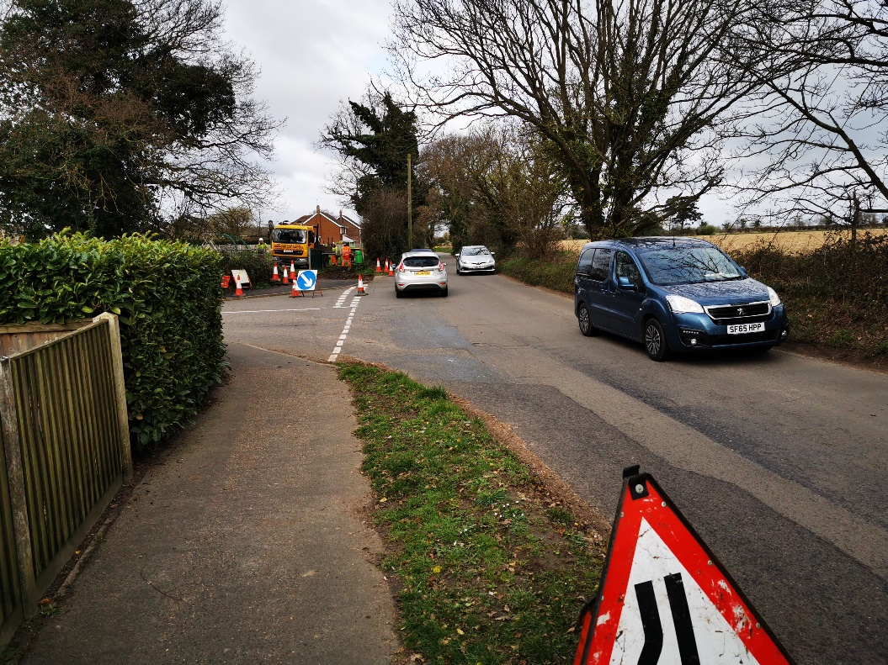
Traffic calming measures e.g. sleeping policemen would require lighting – but we live in a dark village! Putting in lighting in the area would be to the detriment of the character of the village.
Increased traffic and congestion – the volume of additional car journeys per day could be in the hundreds. The Post Office Road is already very busy and at times is used as a rat run when there are problems on the A47. Have traffic studies been conducted to look into the impact on the village?
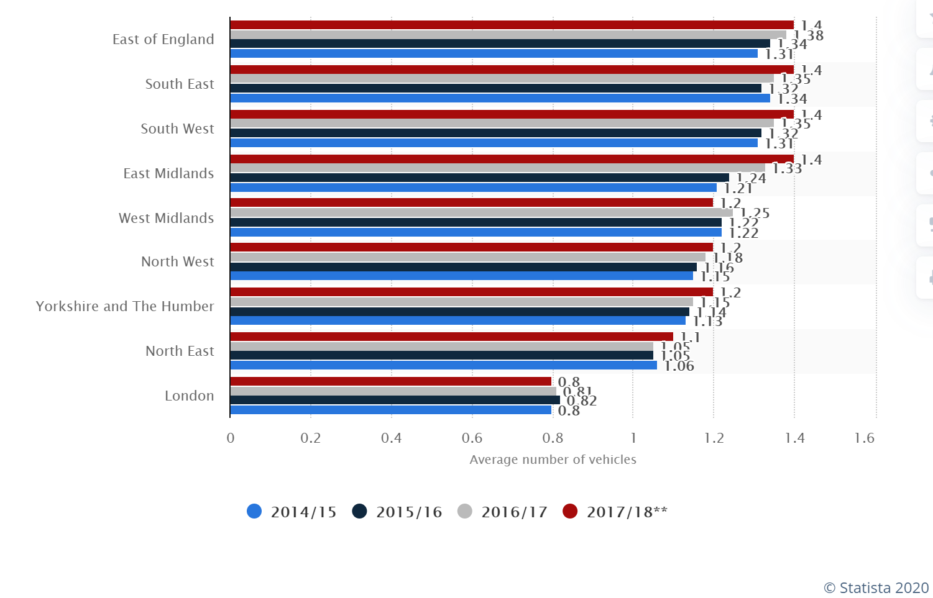
East of England has the joint highest number in the country of cars per household (source Statista 2020). There will be a massive increase in traffic in and around the village, blocking up the roads particularly at school run times and at the start and finish of each working day. Will you be widening all the roads which feed into the village? – they are already narrow and dangerous – and very busy. The Blofield Road is already a terribly unsafe road. It is a single-track road with passing places. It is already very busy and had a recent fatality within a ¼ mile from the proposed site.
There are no job opportunities in the village – where are the people going to work? – surely closer to Norwich or Gt Yarmouth makes more sense as new dwellers will have to travel (most likely in their cars) to get to a place of work!
Increase in traffic will be a danger to our school children who often use the Millennium Park next to the proposed site – there can’t really be a worse site to consider given the proximity to the park and the safety of Post Office Road. There is already an issue with parking in Post Office Close. People (who live in and outside of Lingwood) take their children to the park and park at the entrance to Post Office Close.
Flood risk
Gov.uk website (on 13th March 2020) identifies Post Office Road as a medium flood risk already (see diagram below).
The plan says that the road will be widened to 5.5m with a 2m walkway. If you do that you will then have to take away the ditch which runs along the edge of the field – it is the only protection again the road getting flooded!!!! If you build on the site then the flood risk will be heightened as there will be no natural barrier – what measures are planned to prevent flooding!?
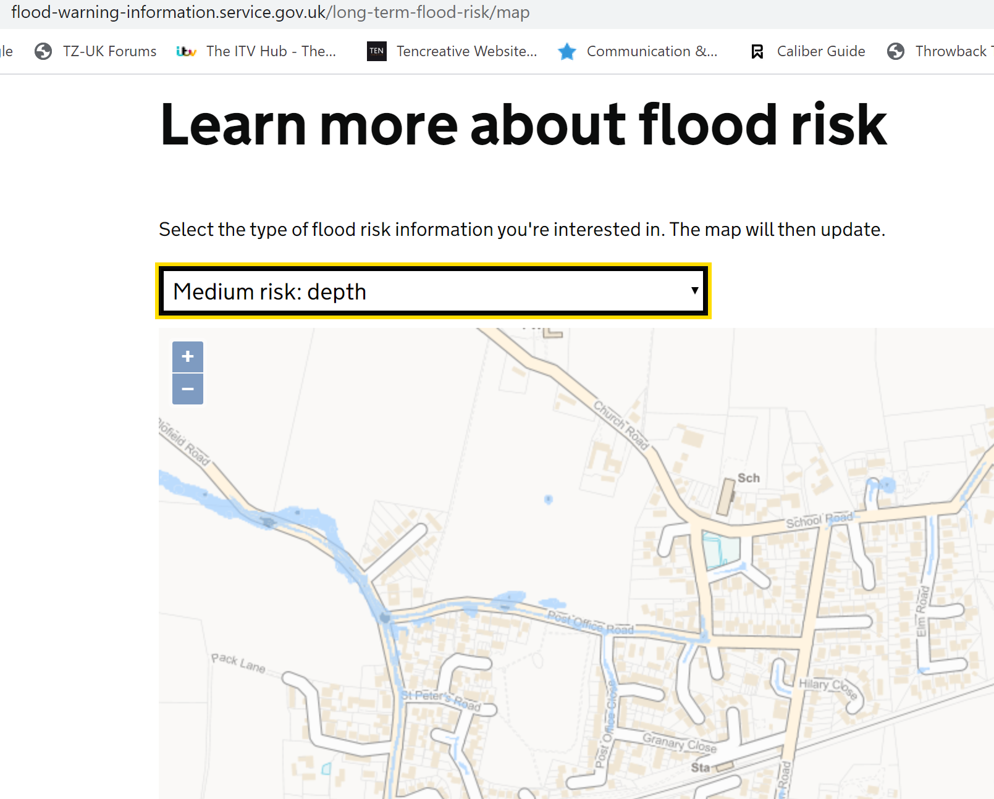
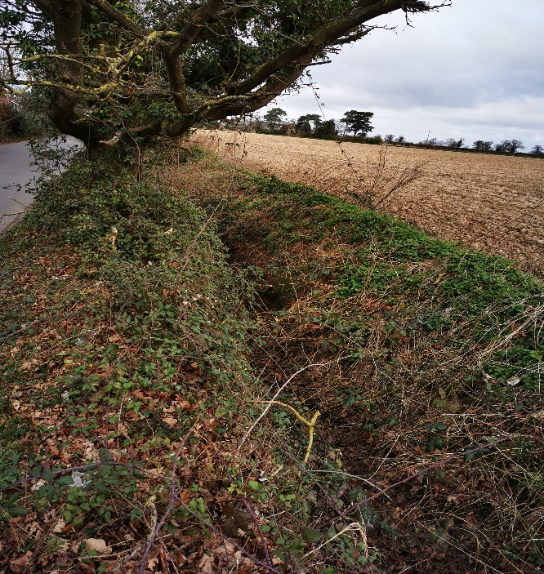
Sewage
The sewerage system for the surround area is very dated – built for far fewer houses than it now serves. Any increase in the number of residences will put severe strain on the system and its ability to cope. A recent new housing development in Blofield was built on unsuitable land and the brand-new houses had to be evacuated due to flood and sewage issues. Are you going to put a new sewage system in the village to support the new building proposed?

Village Infrastructure

We have no medical centre in the village and surrounding villages medical centres are nearly full, some are already full and no longer taking any patients.
We only have one shop and a chippy – and parking at these facilities is poor. Difficulty in parking at these facilities causes frustration and compromises safety at that crossroads. This situation can only get worse if new houses are built in Lingwood. Will there be a Doctors Surgery in Lingwood to address this issue?

Effect on wildlife and biodiversity

Our property directly backs on to the proposed site. We have bats, owls, hedgehogs, frogs, deer, pheasants and partridges regularly visit our garden. Many of these animals come into our garden directly from the field adjacent to Post Office Road. Building on this land will greatly affect the natural habitat of these animals.

In order to widen the Post Office Road to the proposed width (and losing the flood protecting ditch) a number of established trees and hedges would be lost – affecting local wildlife, and very likely involve a compulsory purchase order of garden from at least one property.
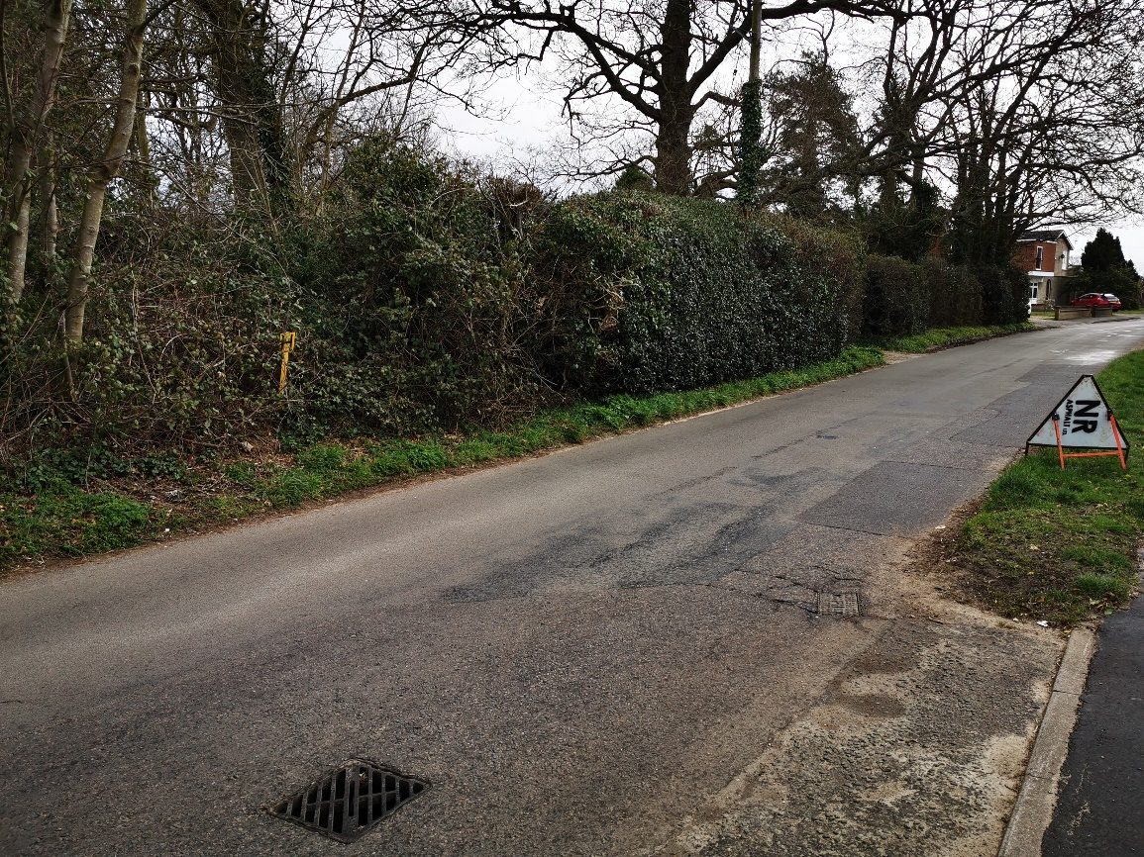
The agricultural value of the land is graded by ALC as Level 1 to 2, meaning ‘land of no or minor limitations’. A very wide range of agricultural opportunities and high yields are possible and less variable than on land of lower quality.
Which trees and hedgerows would be removed along Post Office Road? Are any of them protected?

View of Medieval church from Post office Road

There is an unspoiled view of St Peters Church from Post Office Road and from properties adjacent to the proposed site. St Peters Church is the most prized building in the whole of Lingwood and is a Grade 1 Medieval church (possibly Norman or Saxon) over open farmland – dating back to 1190-1300. Roy Tricker an accomplished authority on Medieval churches has commented extensively on the significance of St Peters church and its importance.
In the Broadland District Council document – Landscape Character Assessment Documents (part 3 of 5) from 2019 – it states
The following Inherent landscape sensitivities have been identified:
- predominantly open, rural character
- sparse settlement in the form of ancient dispersed Hamlets and isolated farmsteads. Their landscape setting and cohesive building materials is vulnerable to unsympathetic additions or extensions, which would disrupt the largely intact built character.
- Subtle features of the historic landscape, such as ponds pits hedgerows, tracks, which are not protected, and are vulnerable to change and loss.
- landscape setting of Manor houses, halls and churches.
- Wide expansive views over a fast and simple landscape with sweeping arable fields
- Exposed character in peripheral parts with partial views over descending wooded slopes to the Broads and associated strong but low horizon.
- Smooth and predominantly uninterrupted skyline.
- Sense of peace and isolation throughout the area.

Landscape Planning Guidelines
Refer to ‘Strategic Gap’, with identified and fully documented intrinsic landscape character value 3.6.28 the following landscape planning guidelines applied to the Freethorpe Plateau Farmland Landscape Character Type:
- seek to conserve the open, rural character of the area
- resist new development that would result in any depletion of the sparsely settled nature of the area or in any reduction in the sense of peace and isolation within the area which is devoid of large settlements
- seek to conserve subtle features of the historic landscape, including hedgerows and tracks
- seek to conserve the landscape setting of Manor houses halls and churches seek to maintain key views towards churches which are often key landscape features
- seek to conserve the landscape setting of Lingwood
- seek to ensure new development does not disrupt the smooth, predominately uninterrupted skyline within the area
- seek to conserve open views across the farmland
- Seek to maintain the traditional character of isolated farmsteads
- seek opportunities for the restoration of hedgerows where fragmented
- seek to ensure that potential new developments comprise a fully integrated landscape and urban design strategy, which is consistent with the local landscape character and screen protected harsh settlement edges

The National Planning Policy Framework, (NPPF) 2012 (section 11) - Conserving and enhancing the natural environment), states that the planning system should contribute to and enhance the natural and local environment. In addition, under plan making section paragraph 170 states where appropriate, landscape character assessment should also be prepared, integrated with assessment of historic landscape character, and for areas where there are major expansion options assessment of landscape sensitivity.
The GNLP even quotes that it will seek to use brown-field rather than greenfield sites…..’We will continue to protect the most valued parts of our area and enhance green infrastructure for nature and people. To help to do this, the GNLP will maximise the amount of development on brownfield sites and make sure that knew development improved the green infrastructure network. Where we have to identify Greenfield sites for development, we will base our decisions on evidence which will enable us to provide new green space, protect valuable landscapes’ - this doesn’t appear to be true for this site! – Why? If you build on this site it will be lost forever!
The village has a brownfield site – the Old School – why isn’t this being developed? – it is an eyesore for the village – will much litter being thrown over the fence

Ambiguous nature of plans
We are being expected to comment on a site with no actual plan presented – you can’t even say how many homes are being proposed to be built will be on there.
there are several ambiguities in the proposal including:
- The site is likely to accommodate 50 to 60 homes, 33% of which will be affordable. More homes may be accommodated subject to an acceptable design and layout being achieved
- there may or may not be landscaping done to this site
- no details of access points from the proposed site
- no idea of size or location of houses
- no understanding of why the scope has increased from a total of 50 to 60 houses to state “More homes subject to an acceptable design being achieved”
- there are no proposals to mitigate against the increased traffic entering the village when these developments are undertaken added to the loss of an entry road due to the joining of a 47
how can this be a true consultation we don't actually know what we are being consulted on?

Possibly better Suited alternative sites

The Old School Site – 20140979 – must be developed – it is a brownfield site and is and absolute eyesore for the village! Why isn’t this in the plan?
Without extensive work being carried out to the roads which feed into Lingwood – especially Blofield Road, I don’t believe that any other sites should be developed.
If Blofield Road is widened then perhaps GNLP0380, combined with the Old School site could provide the necessary number of dwellings. Though the Village infrastructure and traffic issues are still prevalent.
If a larger site is needed, then GNLP0296 was already identified as the preferred site in 2018 – with very strong supporting arguments put forward by Brown and Co in March 2018. What changed to take away the preferential status of the site? https://gnlp.oc2.uk/readdoc/reps/4808
GNLP0296 is closer to the small number of facilities we have and would be even closer (walking distance) to the school. Although the village infrastructure, road congestion and facilities issues would still be prevalent.

